Benjamin Sullivan Curriculum Vitae
8 Duddery Road, Haverhill, Suffolk, CB9 8EA
07929 046869 mail@benjaminsullivan.co.uk

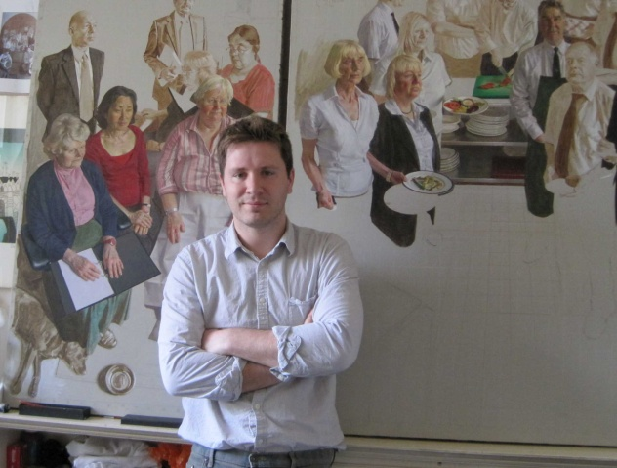
Benjamin Sullivan was born in Grimsby in 1977. He studied painting and drawing at Edinburgh College of Art, graduating in 2000. Since then, he has established a growing reputation as a figurative painter.
His work has been widely exhibited, including at the Royal Academy and National Portrait Gallery. Among other distinctions, he has received a Carrol Foundation Award, the Kinross Scholarship, and a grant from the Elizabeth Greenshields Foundation. In 2007 he won the Lynn Painter-Stainers Prize.
He was elected a member of the New English Art Club and the Royal Society of Portrait Painters in 2001 and 2003 respectively, becoming the youngest person to be elected to those institutions. In 2009, he was made a Freeman of the Worshipful Company of Painter-Stainers.
His work is to be found in numerous public and private collections, including the National Portrait Gallery, the Royal Scottish Academy, Parliament House, Edinburgh, and several Oxford and Cambridge Colleges.
In 2009 he became artist in residence at All Souls College where he undertook a large commission depicting the College staff. The resulting work, The All Souls Triptych, was displayed at the Ashmolean Museum in 2012 and now sits in one of Hawksmoor’s twin towers at All Souls College. In 2014 Sullivan was appointed Artist in Residence at the Reform Club.
He lives and works in Suffolk.

Cont….

Born
1977 Grimsby, N.E. Lincolnshire.
Education
1997-2000 B.A.(Hons), Drawing & Painting, Edinburgh College of Art.
1996-1997 Foundation Course, Grimsby College of Art & Design.

Solo Exhibitions
2012 The All Souls Triptych, Ashmolean Museum, Oxford

Group Exhibitions

2014 BP Portrait Award, National Portrait Gallery, London
Royal Society of Portrait Painters Annual Exhibition, Mall Galleries, London
Discerning Eye exhibition, Mall Galleries, London
2013 BP Portrait Award, National Portrait Gallery, London
Royal Society of Portrait Painters Annual Exhibition, Mall Galleries, London
Royal Academy Summer Exhibition, Royal Academy of Arts, London
2012 BP Portrait Award, National Portrait Gallery, London
Royal Society of Portrait Painters Annual Exhibition, Mall Galleries, London
2011 BP Portrait Award, National Portrait Gallery, London
Royal Society of Portrait Painters Annual Exhibition, Mall Galleries, London
2010 BP Portrait Award, National Portrait Gallery, London
Royal Society of Portrait Painters Annual Exhibition, Mall Galleries, London
The British Are Coming, University of Kentucky and touring, USA
2009 Portraits of Astronomers, National Portrait Gallery, London
BP Portrait Award, National Portrait Gallery, London
Royal Society of Portrait Painters Annual Exhibition, Mall Galleries, London
cont….
2008 Royal Society of Portrait Painters Annual Exhibition, Mall Galleries, London
B.P. Portrait Award Exhibition, National Portrait Gallery, London
Benjamin Sullivan and Toby Wiggins, St Barbe Museum, Lymington, Hants
NEAC Annual Exhibition, Mall Galleries, London
2007 Royal Society of Portrait Painters Annual Exhibition, Mall Galleries, London
NEAC Exhibition, Crossgate Gallery, Lexington, Kentucky, USA
NEAC Exhibition, Alresford Gallery, Hampshire
NEAC Exhibition, The Great Barn, Devon
B.P. Portrait Award Exhibition, National Portrait Gallery, London
NEAC Summer Exhibition, Bankside Gallery, London
NEAC Exhibition, Hereford City Art Gallery
NEAC Annual Exhibition, Mall Galleries, London
The Lynn Painter Stainers Prize Exhibition, Painter's Hall, London
2006 Royal Society of Portrait Painters Annual Exhibition, Mall Galleries, London
B.P. Portrait Award Exhibition, National Portrait Gallery, London
NEAC Annual Exhibition, Mall Galleries, London
The Lynn Painter Stainers Prize Exhibition, Painter's Hall, London
Benjamin Sullivan and Ruth Stage, Oakham Gallery, London
2005 Royal Society of Portrait Painters Annual Exhibition, Mall Galleries, London
NEAC Annual Exhibition, Mall Galleries, London
NEAC Summer Exhibition, Bankside Gallery, London
2004 Royal Society of Portrait Painters Annual Exhibition, Mall Galleries, London
NEAC Annual Exhibition, Mall Galleries, London
2003 Royal Society of Portrait Painters Annual Exhibition, Mall Galleries, London
NEAC by the Thames, Bankside Gallery, London
NEAC Annual Exhibition, Mall Galleries, London
2002 The Hunting Art Prize, Royal College of Art, London
Pastel Society Exhibition, Mall Galleries, London
Royal Society of Portrait Painters Annual Exhibition, Mall Galleries, London
Royal Academy Summer Exhibition, Royal Academy of Arts, London
Royal Society of Portrait Painters: Prize-winners Exhibition, NPG, London
NEAC Annual Exhibition, Mall Galleries, London
B.P Portrait Award Exhibition, National Portrait Gallery, London
The Discerning Eye Exhibition, Mall Galleries, London
2001 The Hunting Art Prize, Royal College of Art, London
Royal Society of Portrait Painters Annual Exhibition, Mall Galleries, London
NEAC Annual Exhibition, Mall Galleries, London
The Discerning Eye Exhibition, Mall Galleries, London
2000 Royal Scottish Academy Student Exhibition, Edinburgh
Two Counties Art Exhibition, Highcliff Castle, Dorset
NEAC Annual Exhibition, Mall Galleries, London
cont….

Residencies
All Souls College, Oxford, 2009 – 2010
The Reform club, Pall Mall, 2014 - 2015
Awards
Elisabeth Greenshields Grant, Quebec, Canada
Carrol Foundation Prize, Royal Society of Portrait Painters, London
Young Artist of the Year Runner-up Prize, Hunting Art Prize, London
Purvis Prize for Painting, NEAC, London (2000,2001)
Worshipful Company of Painter Stainers Prize, NEAC, London
John Kinross Scholarship to Florence, Royal Scottish Academy, Edinburgh
Manya Igel Fine Art Scholarship, NEAC, London
Andrew Grant Memorial Scholarship, Edinburgh College of Art
Winner of the Lynn Painter Stainers Prize 2007
Bill Patterson Memorial Prize, NEAC, London
Discerning Eye Regional Artist Prize, 2014
Collections
Royal Scottish Academy, Edinburgh
Parliament House, Edinburgh
Institute of Civil Engineers, London
University College, Oxford
All Souls College, Oxford
Girton College, Cambridge
National Portrait Gallery, London
The Queen’s College, Oxford
Worshipful Company of Furniture Makers
Standard Chartered
The Royal Mint
Bradfield College
Eton College
Rugby School
The Reform Club

Memberships
New English Art Club (NEAC)
Royal Society of Portrait Painters (RP)
Worshipful Company of Painter-Stainers

